Networking Fundamentals
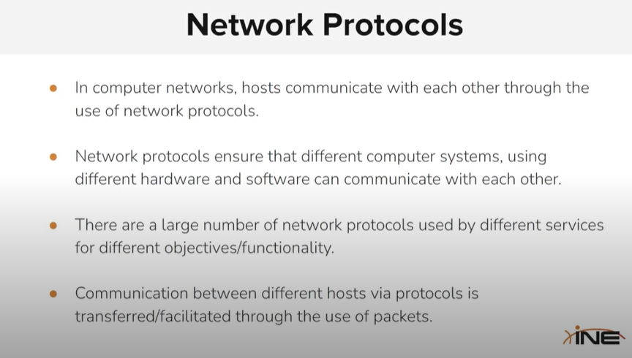

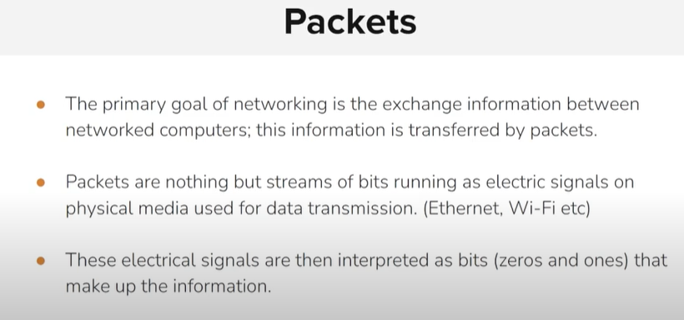

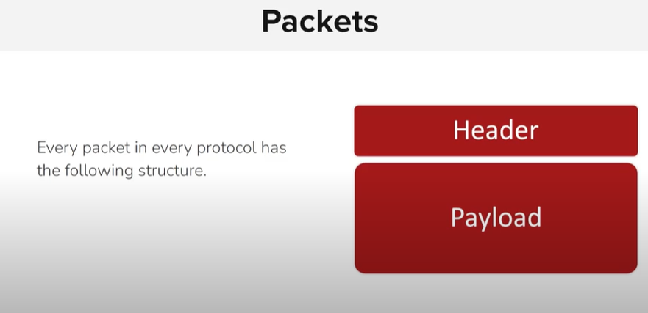

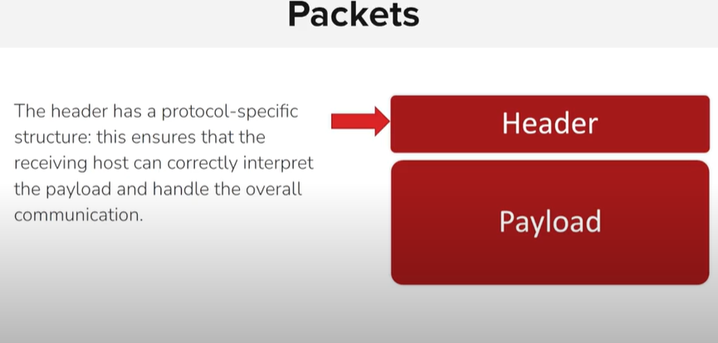

Tcp ip means that it works only on ip protocol of network layer.
Rpc = remote procedure call

🔹 API (Application Programming Interface):
Allows programs to initiate and manage sessions for communication between software components across a network.
🔹 NetBIOS (Network Basic Input/Output System):
Provides session-level communication services for name resolution and connection between Windows-based computers.
🔹 RPC (Remote Procedure Call):
Enables a program to execute functions on a remote system, managing the session and data exchange transparently.

